DOCUMENT TYPE: Standard Operating Procedure
TITLE: Flow Check on BAM 1020 (Audit)

PREPARED BY: Pamela Atcitty 7/03/13
Tribal Air Program (Date)

REVIEWED BY:
Environmental Technician (Date)

APPROVED BY:
Environmental Department Manager (Date)

Table of Contents

- Scope of Application……………………………………………………………………………………………….1
- Summary of Method………………………………………………………………………………………….…….1
- Interferences/Comments……………………………………………………………………………………………1
- Supplies………………………………………………………………………………………………….………….2
- Procedures Setups………………………………………………………………………..……………………….2-3
- Troubleshooting…………………………………………………………………………….……………………….3

Scope of Application

Quality Control (QC) is the overall system of technical activities that measures the attributes and performance of a process, item, or service against defined standards to verify that they meet the stated requirements established by the tribe. Day-to-day quality control is implemented through the use of various checks or instruments that are used for comparison.

Summary of Method

Place BAM 1020 in “maintenance mode”

Correct readings

Measure volumetric flow

Reassemble BAM 1020

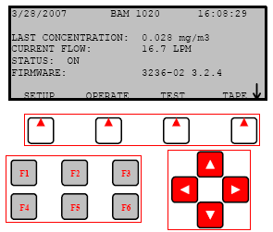
Interferences/Comments

The volumetric flow check requires the use of the BX-307 Flow Calibrator. Consult the SOP titled “Operating the BX-307”.
  - Using the BAM-1020 Keypad/Display: This main menu screen is the starting point for all functions of the BAM and can be accessed from any screen by selecting EXIT.
    - Soft keys: Four white buttons directly beneath the display changes in response to a menu option above.
    - Function keys: Used for entering password F1,F2,F3,F4
    - Arrow keys: Used to navigate up, down, left and right
  - A flow rate verification check of the sampler flow rate is recommended every month. Control charts presenting flow rate verification check data (indicated vs. measured) should be maintained.
  - The below procedures are for flow “check” or “audit” in which no BAM calibrations are to be changed.
  - Compare the BAM column reading to your standard device for each parameter, and record the results. No calibrations are altered if the CAL or DEFAULT keys are not pressed.
  - If calibration is required see SOP titled “Flow Calibration on BAM 1020”

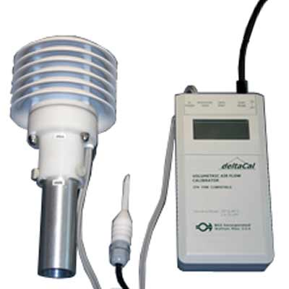
Supplies

BX-307 Flow Calibrator (located in black case the workstation’s cabinet)
  - BAM-1020 Calibration Sheet (located on clipboard on west wall)

Procedure

Install BX-307Flow Calibrator

On the shelter’s roof, turn on the BX-307 Flow Calibrator (standard-STD) and set it aside to allow the unit to self stabilize (this can be done before the leak check is performed).

Remove the PM10 head (or BX-302 leak check valve, if performing after leak check) and the VSCC from inlet and install the BX-307 Flow Calibrator, wrapping the box’s cord around bi-pod’s leg as to keep the box from dangling freely.

Obtain Temperature and Barometric Pressure readings

Take note of the BX-307 temperature and barometric pressure readings and enter these two values on the BAM-1020 Calibration Sheet under “Ref. Temperature” and “Ref. Pressure”.

Compare Temperature and Barometric Reading into BAM-1020 STD field

At the BAM’s main menu screen press the TEST soft key then select FLOW.

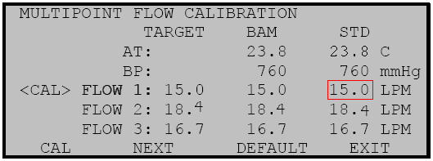
Enter password: F1, F2, F3, F4

The “Multipoint Flow Calibration” screen will appear. Compare the BAM’s Ambient Temperature (AT) and Barometric Pressure (BP) to the values obtained from standard device, BX-307 in step 5.2.1

If AT is within ±2°C select NEXT soft key.

If BP is within ±10 mmHg, select NEXT soft key.

Verify Flow 1,2, and 3

Flow 1: On the BAM press the NEXT key to select the first flow point of 15.0 L/min. The BAM-1020 pump will turn on automatically. Allow the unit to regulate the flow until the BAM reading stabilizes at the target flow rate of 15.0 L/min.

Return to the shelter’s roof and allow the BX-307 to stabilize. Once stabilized, take note of the volumetric flow rate value (Qa).

Return to the BAM-1020 and compare the standard device, BX-307 (Qa) value to the BAM field for FLOW 1. These are simple checks and no calibrations are required.

Flow 2: Press NEXT key to select the second flow point of 18.4 L/min. Allow the flow to stabilize again.

Take note of the new volumetric flow rate value (Qa) on the BX-307at the shelter’s roof.

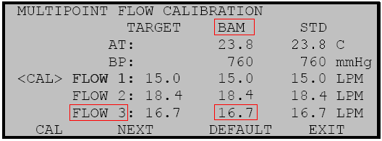
Compare this value to the BAM field for FLOW 2 and press the NEXT key.

Flow 3: Press the NEXT key to select the third flow point of 16.7 L/min. Allow the flow to stabilize then write the value from the BAM column for FLOW 3 onto the Calibration sheet under “BAM Flow”.

At the shelter’s roof, check the volumetric flow rate value (Qa) on the BX-307 and enter this value onto the Calibration sheet under “Ref. Flow”.

If the percentage difference is less than 2%, select the NEXT soft key.

Remove BX307 and replace both PM heads.

Complete BAM Calibration Checklist.

Troubleshooting

Refer to the BAM 1020 Particulate Monitor Operation Manual

